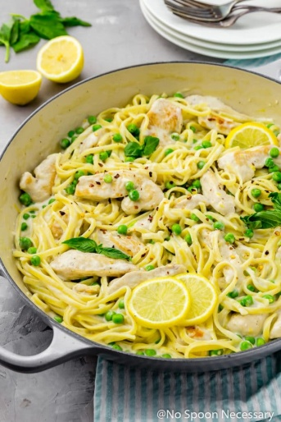
Lemon Garlic Chicken

Prep Time 8 min Cook Time 20 min

4 Servings
Ingredients
2 boneless chicken thighs
½ tsp garlic powder
2 tbsp olive oil
3 tbsp butter
1 onion, chopped
4 garlic cloves, sliced or minced
1½ tbsp Italian seasoning
Juice and zest of 2 lemons
1 ⅓ cup homemade or low sodium chicken broth
1 cup heavy cream
Chopped fresh parsley and lemon slices for garnish, if desired

Directions
- Season the chicken on both sides with salt, pepper and garlic powder and add the chicken in one layer to the pan.
- In a medium-sized skillet over medium-high heat add olive and cook for 5-6 minutes on each side, or until chicken reaches 165 degrees. Transfer browned chicken to plate. Set aside to rest and cube or shred.
- Melt butter and stir in the onions and garlic. Add lemon juice to deglaze pan. Cook for 1 minute then add Italian seasoning, lemon zest, and chicken broth. Stir to combine.
- Stir in heavy cream. Once the sauce has bubbled and thickened up slightly, add the chicken back into the pan until hot.
- Sprinkle chicken with chopped parsley and serve hot with your favorite sides. Spoon sauce over chicken and garnish with lemon slices, if desired.

